Sedgewick, Jacob
[Company name] [Company address]
Student Course Registration System

Contents
Use Case Diagram 2
Entity Relationship Diagrams 3
Data Dictionary 4
Class Diagrams 5

Use Case Diagram
  - Actors
- Student
- Teacher
- Admin
  - Cases
- Register for course
- View Timetable
- Manage Payments
- Manage Course offerings
- Approve Registrations
- Generate reports
- View enrolled Students
- Upload Grades
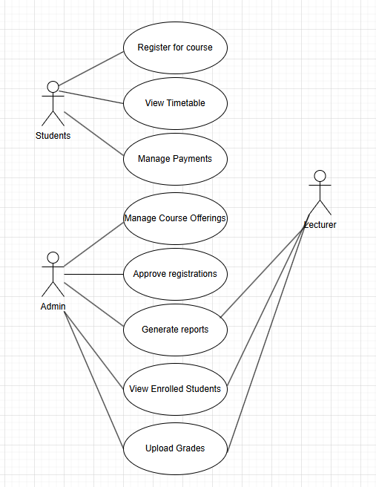
This helps Technical Stakeholders because they can see what tasks each user is going to perform and helps form an idea about what data will be stored within the system.
This helps non-technical Stakeholder because they can see what each user wants to do and can see the actions they are going to perform.

Entity Relationship Diagrams
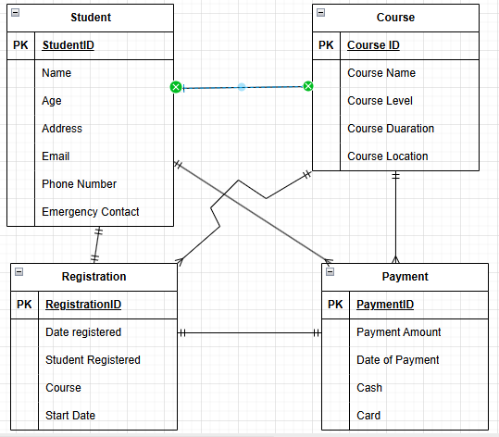

This helps Technical Stakeholders because they can see what type of data is stored inside each of the tables helping them form an idea of the code and how it is going to look and helps us see the relationships between the different entities and tables.
This helps non-technical Stakeholder because they can see the attributes that will be in each table and will be able to give feedback on the data in case any is unnecessary which would help us improve the efficiency of the system.

Data Dictionary
Table name | Field name | Field Definition | Data Type & Length | Format/Validation Rules | Sample Data
Student | StudentID | Specific 8-digit number for student | int(8) | Must be 8 integers long | 12345678
 | Name | Name of student | VarChar (100) | Must be alphabetical | John
 | Age | Age of student | int(3) | Must be numerical | 23
 | Address | Address of where student lives | VarChar (300) | Must contain Street name and number and Postcode | 8a Countisbry Road  TS20 8AU
 | Phone Number | Phone number of students | Int(15) | Must be 15 numbers long | 123456789012345
 | Email | Email of student | VarChar(300) | Must include @ + .com | jsedge@gmail.com
 | Emergency Contact | Phone number of emergency contact | Int(15) | Must be 15 numbers long | 123456789012345

This helps Technical Stakeholders because they can see what attributes go into each type of data allowing us to start planning how we are going to gather the data and keep it safe to help follow laws and regulations such as the GDPR.
This helps non-technical Stakeholder because they can see the sample data which will help them understand what type of data may go into the system.

Class Diagrams
This helps Technical Stakeholders because they can see the different classes’ attributes, methods and can start planning out the code from there and helps them see the relationships between the different classes.
This helps non-technical Stakeholder because they can see the different classes link and what goes into the different classes.

